This master should be used by designers working on Port of Portland construction projects and by designers working for PDX tenants (“Tenants”). Usage notes highlight a few specific editing choices, however the entire section should be evaluated and edited to fit specific project needs.

SECTION 280553 – IDENTIFICATION FOR FIRE ALARM SYSTEMS

1. GENERAL
   * + 1. DESCRIPTION
          1. This section describes labeling requirements for a fire alarm system including, but not limited to, the following:

Initiating devices.

Input and output modules.

Notification appliances and circuits.

Fire alarm wire and cable.

Fire alarm panels.

Message labels.

* + - 1. RELATED WORK SPECIFIED ELSEWHERE
         1. Section 260500, Common Work Results for Electrical Systems
         2. Section 260553, Identification for Electrical Systems
         3. Section 271000, Structured Cabling
         4. Section 284600, Fire Detection and Alarm
      2. REFERENCES
         1. ANSI: American National Standards Institute

ANSI Z535.4: Product Safety Signs and Labels.

* + - * 1. ISO: International Organization for Standardization.
        2. NFPA: National Fire Protection Association

NFPA 3: Standard for Commissioning of Fire Protection and Life Safety Systems.

NFPA 70: National Electrical Code (NEC).

NFPA 72: National Fire Alarm and Signaling Code.

NFPA 170: Standard for Fire Safety and Emergency Symbols.

* + - 1. SUBMITTALS
         1. Coordinate with the Port to obtain the latest version of the Fire Alarm Device Schedule for the project. Enter device bar codes and warranty start dates for audible and visual notification appliances and circuits into the schedule. Submit to the Port for review and approval prior to commencing work.
         2. Submit a sample UV-resistant vinyl tape label.

1. PRODUCTS
   * + 1. LABELS, GENERAL
          1. Pre‑Printed: Permanent material pre‑printed white labels with adhesive backing or wire sleeve. Brady, 3M, or equal. Dymo tape or hand-written labels are not allowed.
          2. Laminated Plastic: 3‑ply laminated plastic, professionally engraved, with 1‑inch high red letters. Lamicoid, or equal. Font shall be Arial in capital letters. Attach labels using appropriate adhesive glue.
          3. UV-Resistant Vinyl Tape: Self-adhesive, thermal transfer 4” x 6” UV-resistant vinyl label. White background with a 1” yellow stripe. Cascade Labeling High-Tack Industrial Label Tape, or equal.
2. EXECUTION
   * + 1. INITIATING DEVICES
          1. Use pre-printed labels with red text.
          2. Indicate the device logical address, which includes fire alarm control panel number, card number, and initiating device logical address (see example below). Also attach the device barcode and serial number that are provided with the device.
          3. Remote LED Labels: Include the equipment that the remote LED is serving in addition to the device logical address.
          4. Input and Output Modules: Place all labels on the module itself or on the bottom of the gang box cover. Do not cover LEDs.
          5. After installation, place all labels on the device and in clear view and recognition from the floor level.
       2. NOTIFICATION APPLIANCES
          1. Use pre-printed labels with black text.
          2. Indicate the notification appliance circuit and device position on circuit. Apply notification appliance label to the most visible part of the device. Do not cover serial numbers.
       3. FIRE ALARM WIRE AND CABLE
          1. Label each cable with pre-printed label at 2 inches from the termination point using the appropriate cable name as indicated.

Input cables: Pre-printed labels with red letters.

Output cables: Pre-printed labels with black letters.

* + - * 1. Complete installation of labels prior to installation of ceiling tiles.
      1. FIRE ALARM CONTROL PANEL (FACP)
         1. Label FACPs and annunciators indicating panel number.

Use laminated labels.

Affix the panel label centered at the top of the panel door.

* + - * 1. Label FACPs indicating electrical source from which the panel is fed.

Use pre-printed labels with red text.

Affix on the left top corner of panel door.

* + - * 1. For annunciator panels, use FAAP as abbreviation and panel number.
      1. FIRE ALARM NOTIFICATION APPLIANCE CIRCUIT PANEL (FANAC)
         1. Label FANAC indicating FACP number and FANAC number.

Use UV resistant vinyl tape labels.

Place panel label centered in the middle of the panel door.

* + - * 1. Labels for FANAC shall include panel number, electrical source from which the panel is fed, NACs addresses and location those serve, trouble signal (TBL), and activation command (ACT) module logical address.
      1. FIRE ALARM TERMINAL CABINET (FATC)
         1. Label FATCs indicating FACP number and FATC number.

Use laminated labels.

Affix the panel label centered at the top of the panel door.

* + - * 1. Label FATCs indicating the notification appliance circuits from which the panel is receiving signals.

Use preprinted labels with red text.

Affix on the left bottom corner of panel door.

* + - * 1. Provide print-screen of 3-SDU (System Definition Utility) generated object configuration list, with protective, clear transparent covers, accurately accounting for every device, monitor, and control module installed, including spares. Schedules shall use the actual LRM (local rail module) label, device type, addresses, label text, and message text. Designations shall match the system design shop drawings.
        2. Provide notification appliance circuit (NAC) power supply wiring drawing with protective, clear transparent covers, accurately showing wiring diagram.

Tenant: Retain the graphics below only if there are no drawings. Port projects: delete the graphics below and include them in the drawings.

* + - 1. LABEL NAMING CONVENTION
         1. Addressable circuit device numbering:

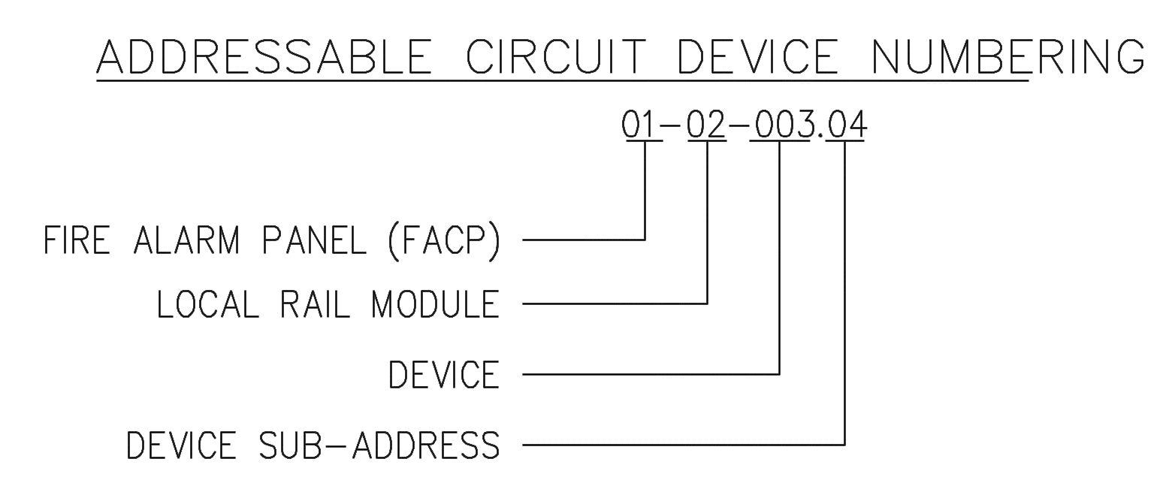

* + - * 1. FANAC identifier:

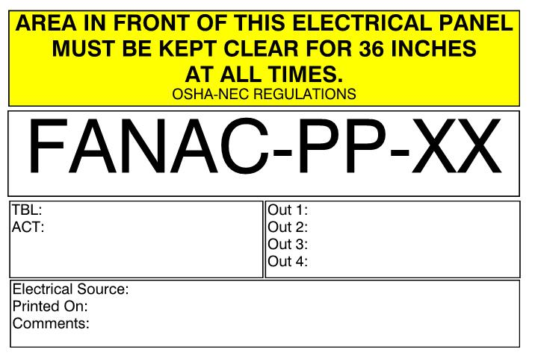

* + - * 1. Notification appliances circuit identifier:

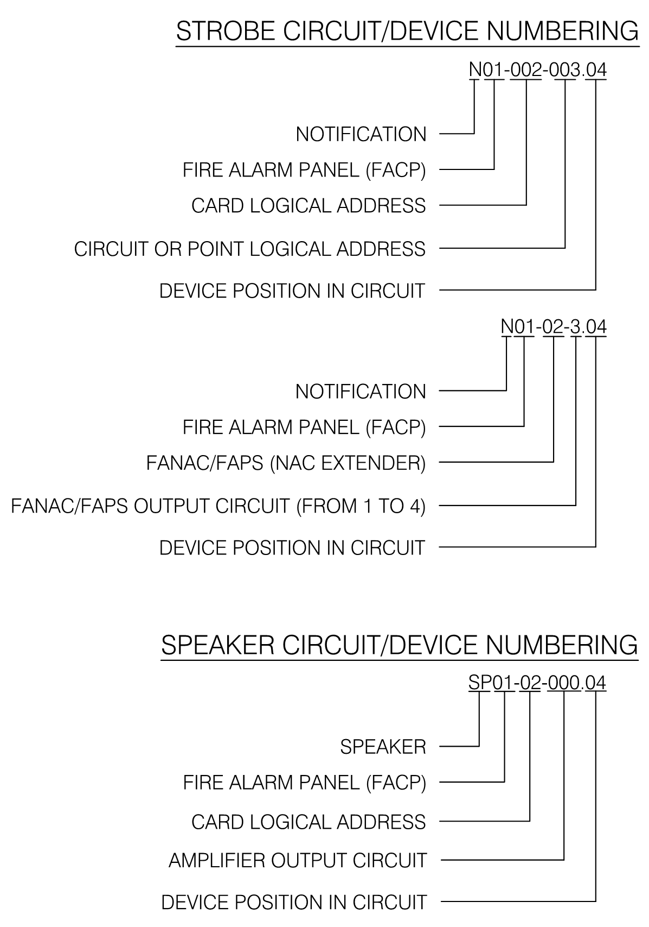

* + - * 1. Fire alarm panels:

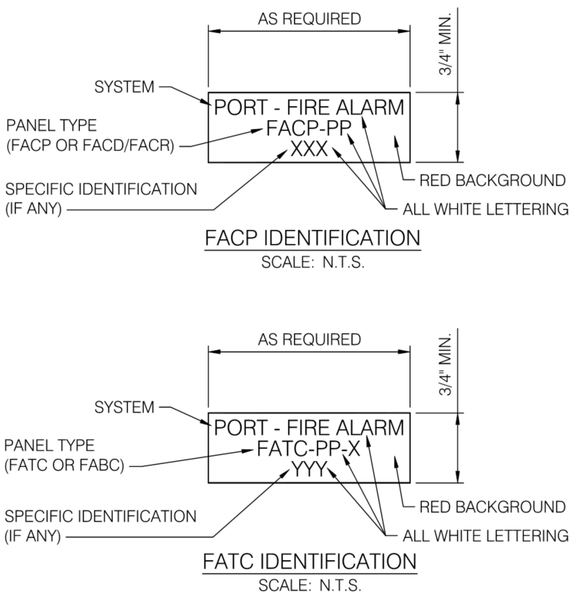

END OF SECTION 280553