**PDX Air Cargo Overview**

**April 2019**

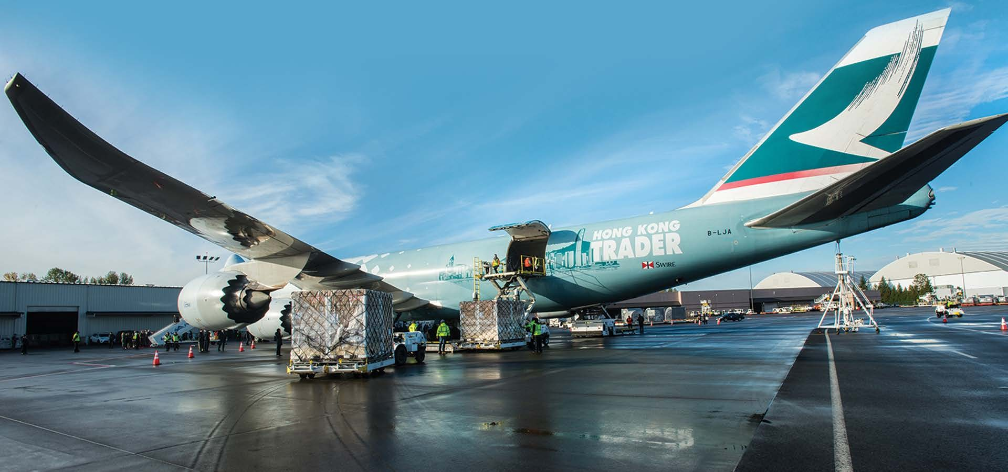

**Cathay Pacific Cargo loads freight for flight to Hong Kong**

**Cathay Pacific Cargo loads freight for flight to Hong Kong**

# PDX Cargo Overview

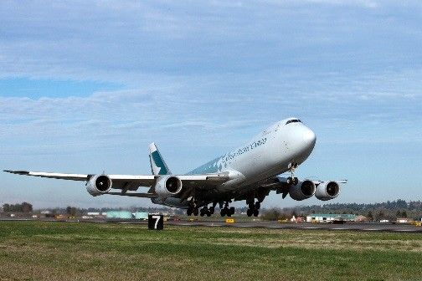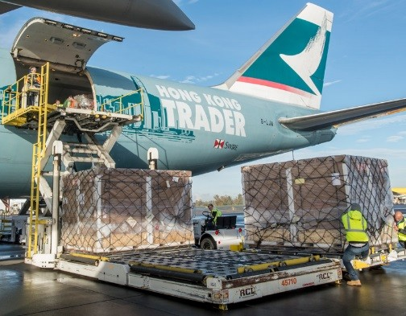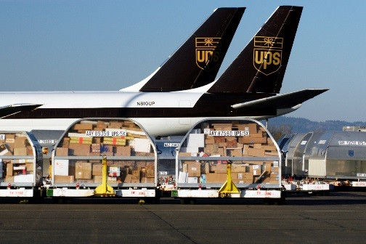

* **Air Cargo Background**
  + **Definitions** – **What moves by air?**
* **PDX Cargo Services**
  + **Mission**
  + **Market area**
* **Supply Chain Story - Role of Air Cargo**
* **Historic and Forecast Cargo Volumes**

# Definition of Terms

* **Cargo:** Freight and air mail
* **Freight:** Goods being shipped
* **Shipper:** Manufacturer or company sending goods
* **Forwarder:** Books/consolidates freight shipments for a company **All Cargo Carrier Integrated Carrier Belly Cargo Carrier**

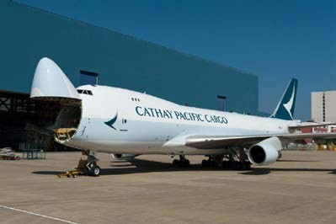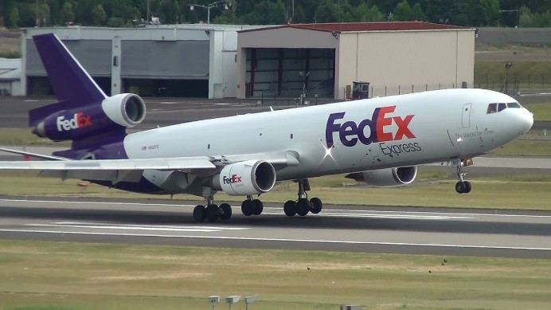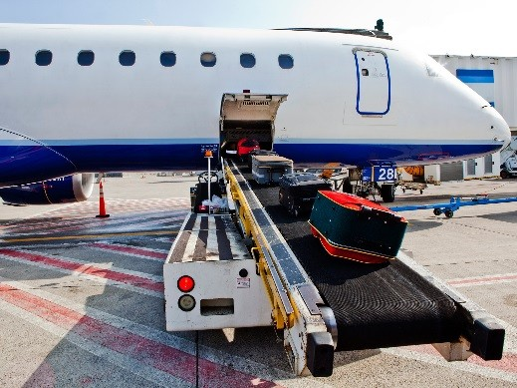

**What Moves by Air?**

* **Hi-Tech**
* **Shoe Components**
* **E-commerce**
* **Documents**
* **Medical Supplies/Equipment**
* **Perishables**
* **High Value Time Sensitive Items**



**What Moves by Air?**

**PDX Area SEA Area**



Footwear

parts

All other

High Tech

Agriculture/

Seafood

**3,063**

**11,539**

**8,247**

**10,540**

**11,236**

**1,880**

**19,320**

Source: US Bureau of the Census, 2017 annual data, as modified by Campbell-Hill Aviation Group

Note: Market area is in Tonnes (MT)

# PDX Services

* **Freighter:** Cathay Pacific to Asia
* **Integrators:** UPS, FedEx, DHL (80% of volume)
* **Belly capacity:** US, Europe, Canada, Asia, Mexico

**Mission:** *enhance the region's economy and quality of life by providing efficient cargo and air passenger access to national and global markets and by promoting industrial development.*

**Freighter service supports region’s high tech, perishables, ecommerce and footwear/apparel industries**.

Air Sole Factory in **5** Beaverton Trucked to Factory in China

**8**

Delivered to

Retail Outlets



**7**

Trucked to

Airport/Marine

Terminal



**6**

Assembled in

Factory

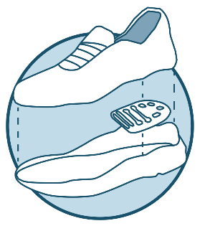

**4**

Flight to Hub.

Connecting flight

to China

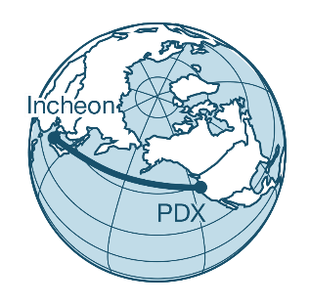

**Supply Chain Story**

**3**

Trucked to Airport.

Loaded on Plane

**2**

Trucked to

Freight

Forwarder

**1**

# PDX Cargo Tonnage (10-year)

**%**

**5**

**%**

**22**

**10**

**%**

**Growth**

0

50,000

100,000

150,000

200,000

250,000

300,000

2008

2009

2010

2011

2012

2013

2014

2015

2016

2017

2018

Tons

**Historical and Forecast Cargo Volumes**

0

0.2

0.4

0.6

0.8

1

1.2

1.4

1975

1985

1995

2005

2015

2025

2035

**Total Cargo (millions of short tons)**

Historical

High

Medium

Low

2010

MP Update

Forecasts

Sources: Summary Report, Master Plan Update, Portland International Airport, June 2010; Port of Portland website.

**Orientation: PDX Cargo Facilities**

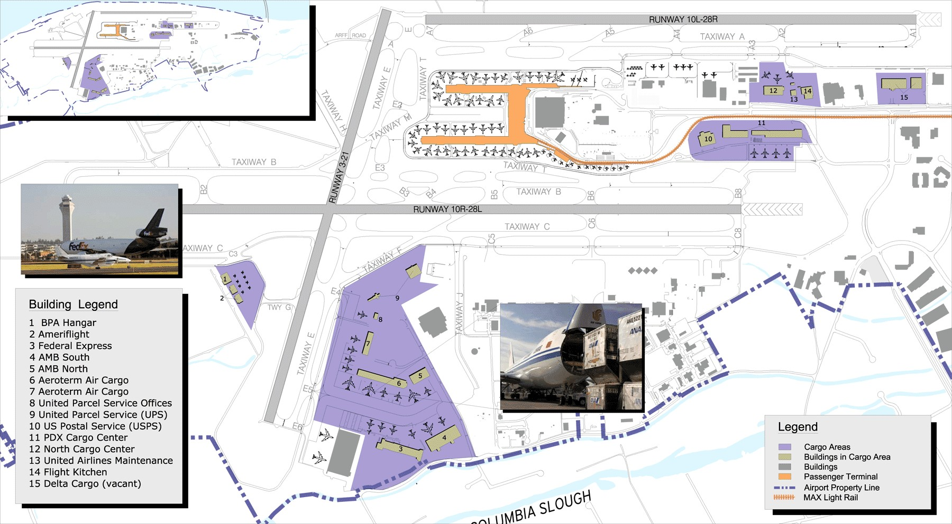

**PDX Cargo**

**Center**

**Northside**

**Redevelopment**

**eliminated former**

**North**

**Cargo Complex**

**Former ORANG**

**Properties**

**Southwest Ramp**

**AirTrans Cargo Center**

**Southside Development Study**

**Airtrans Center and Reserve Area**

Confirm functions and development best accommodated in the Reserve and Airtrans Center (ATC) areas;

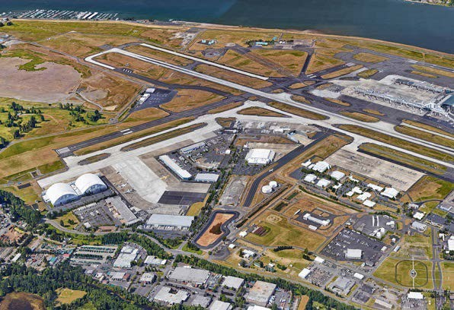

Understand existing capacity and development opportunities; Recommend interim plan and strategy for the Study area.

# Planning Context

* Airport’s belly cargo functions will be accommodated at the PDX Cargo Center
* Integrated cargo functions will be accommodated in Airtrans Center.
* In the next few years aircraft parking will increasing be accommodated closer to the terminal.
* The third parallel runway is not expected to be needed for at least 25 years.
* When Southside properties are fully developed Southwest Quadrant will be the next area suitable to accommodate air cargo and aircraft maintenance needs

# Southside Business Principles

* Functions directly related to PDX activity have priority over functions that could be accommodated at other airports or offairport, for example:
  + Base maintenance of general aviation aircraft (HIO)
  + Flight kitchens (off-airport)
* Non-Aviation uses should be permitted only if
  + They do not conflict with direct aviation needs
  + They add value to existing aviation functions within Study area (e.g., freight forwarders)
  + They are under leases with specific recapture clauses

# Site Assessment Conclusions

* The Study area was well-planned. Parcels are not tightly constrained by airport design criteria.
* Multiple vacant parcels exist.
* Many parcels possess good potential for additional building.
* Overall, only a few sections of ramp within the Study area require maintenance
* Opportunity exists to more efficiently use the ramp for aircraft parking by implementing more active ramp management strategies.

# Market Assessment

* E-commerce and cold storage could change the way typical air cargo markets at PDX operate.
* The air cargo market is evolving to include lower-value goods in large quantities in addition to the historical focus on higher-value goods.
* It is unclear whether recent changes in the cargo market, such as recent growth in total volume and demand for lower-value goods, are long-term trends or temporary market volatility.
* PDX could absorb some excess demand that cannot not be accommodated at SEA due to insufficient facilities.

# Conclusions

* Multiple development opportunities existing
* The highest-value opportunity is to increase the utilization of the existing ramp
* Airtrans Center with the addition of the Oregon Air National Guard Properties is well positioned to meet air cargo and maintenance related demand for the foreseeable future.
* Infill and redevelopment opportunities in the southside study area provide sufficient time to begin to address pre-development requirements for SW Quad.